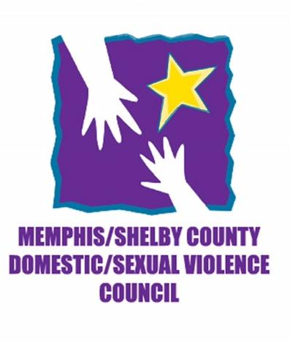
Memphis & Shelby County Domestic & Sexual Violence Council
2018 Membership Form

Name: __________________________________________________
Organization: ____________________________________________
Address: ________________________________________________
Email Address: ___________________________________________
Phone Number: __________________________________________

DUES: $25 – Please make checks payable to Memphis & Shelby County Domestic & Sexual Violence Council – 6025 Stage Road, Box 42 – 330, Bartlett, Tn 38134

